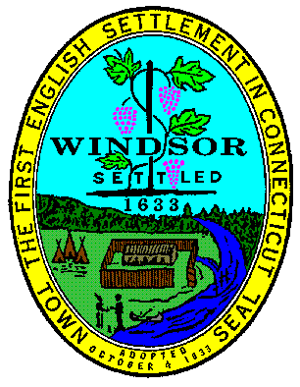
TOWN OF WINDSOR, CONNECTICUT
PUBLIC BUILDING COMMISSION – Hybrid Meeting
June 10, 2025 - 6:30 PM at Town Hall - Ludlow Rm.
By Zoom Webinar, enter or click on link: https://us02web.zoom.us/j/ 85224515655
If you wish to speak during Public Comment press Raise Hand in the webinar
By phone, dial: 1-646-558-8656 then enter Meeting ID: 852 2451 5655 then press #
If you wish to speak during Public Comment press *9 to raise your hand.

AGENDA
- Call to Order
- Remarks of the Chair
- Public Communications
- Town Hall Roof Design – FY 26
- Windsor High School Roof Design – 9592 FY 27
- LP Wilson Roof Replacement- North End – FY 26
- Clover Street School Restrooms ADA Improvements Phase 2 – 9552 FY 25
- LP Wilson HVAC Improvements Phase 1 – 9551 FY 23
- LP Wilson HVAC Improvements Phase 2 – 9551 FY 24
- LP Wilson HVAC & Interior Improvements Phase 2B – 9551 FY 25
- Wilson Fire Station Roof Replacement – 9585 FY 25
- Wilson Fire Station Interior Renovations – 9585 FY 25
- Poquonock Elementary School Roof Design – 9558 FY 25
- Clover Street School Roof Design – 9549 FY 22
- Sage Park School Roof Replacement Phase 2 – 9541 FY 24
- Oliver Ellsworth Humidity Mitigation – 9574 FY 24
- Sage Park MS HVAC Replacement Phase 2 & 3 – 9542 FY 23
- Aquatic Facilities Improvements Goslee & Welch Design – 9536 FY 22
- Welch Pool Renovations Construction – 1938 FY 24
- LP Wilson BOE Restroom Improvements Design – 9553 FY 25
- 330 Windsor Avenue Gym HVAC – 9550 FY 22
- Milo Peck School HVAC Replacement Design – 9538 FY 21
- Minutes of Preceding Meeting
- Staff Reports
- Adjournment

